Gentry English Springer Spaniels (est. 1974)
LeeAnn Gutzwiler – 6255 Leonard, Downers Grove, IL. 60516 (630) 964-7172
GentryES@aol.com www.gentryspringerspaniels.com
Born : _____________________
Sex : ______________________
Color:_____________________
AKC #: ____________________

The information given above is correct to the best of my knowledge. Signed _______________________
Pedigree of _____________________________________
Sire  Ch. Gentry’s N’ Roseline’s  Incognito CD/TD/CGC  “Sly”  OFA/Good eyes/clear  DNA/affected  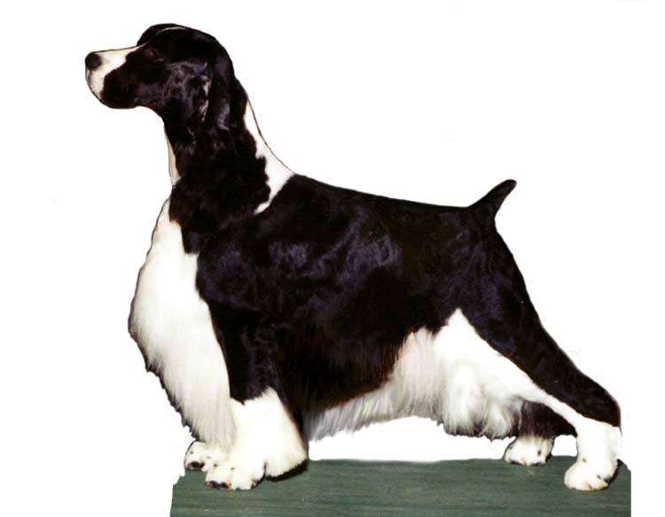 | Sire  Ch. Salilyn’s Recognition | Sire  CH. Salilyn’s  Candidate | Sire Ch. Salilyn’s  Nomination | Sire Ch. Telltale Author
 |  |  |  | Dam Ch. Salilyn’s Special Honor
 |  |  | Dam Ch. Salilyn’s  Welcome Design | Sire Ch. Salilyn’s Design
 |  |  |  | Dam Salilyn’s Preference
 |  | Dam  Ch. Salilyn’s Bacardi | Sire  Ch. Salilyn’s Dynasty | Sire Ch. Telltale Author
 |  |  |  | Dam Ch. Stepney’s Cinderella
 |  |  | Dam  Ch. Salilyn’s Emblem | Sire Ch. Salilyn’s Private Stock
 |  |  |  | Dam Ch. Salilyn’s Prima Donna
 | Dam  Ch. Gentry’s Private Party | Sire  Ch. Salilyn’s Condor | Sire  Ch. Salilyn’s Dynasty | Sire Ch. Telltale Author
 |  |  |  | Dam Ch. Stepney’s Cinderella
 |  |  | Dam  Ch. Salilyn’s Emblem | Sire Ch. Salilyn’s Private Stock
 |  |  |  | Dam Ch. Salilyn’s Prima Donna
 |  | Dam  Ch. Gentry’s Private  Dancer | Sire  Ch. Salilyn’s Private Stock | Sire Ch Felica’s Bequest
 |  |  |  | Dam Ch. Salilyn’s Sonnet
 |  |  | Dam  Ch. Gentry’s Flashdance | Sire Ch. Coventree’s Allegro CD
 |  |  |  | Dam Ch. Gentry’s Caprice CD/WD
Dam  Ch, Gentry’s Girl Code  “Posh”  OFA/Excellent Elbow/normal Eyes/DNA/Normal  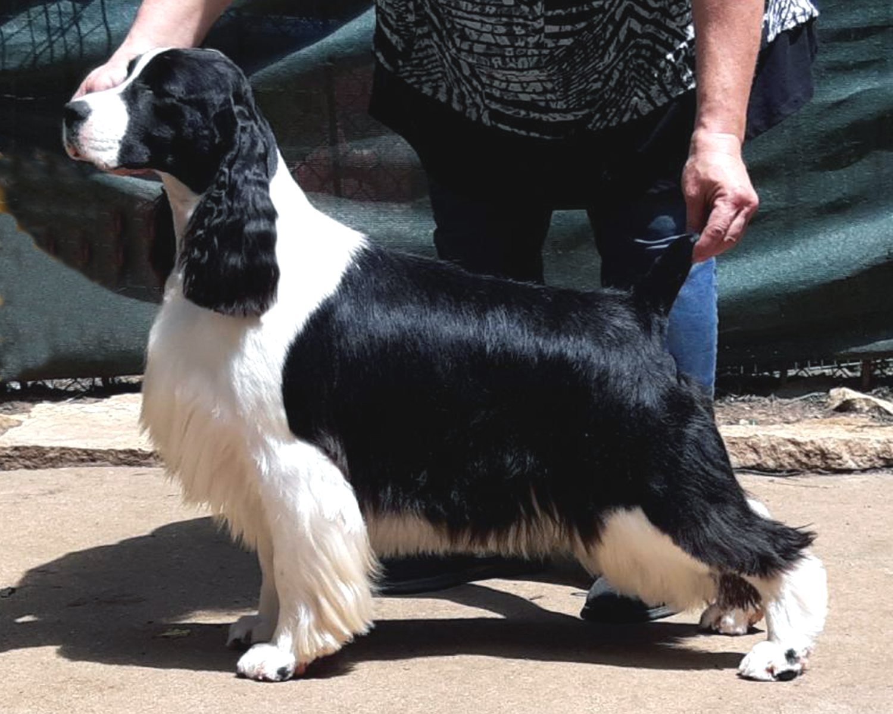 | Sire  BR/GCh. Cerise Bonanza | Sire  GCh. Cerise  Blindside | Sire  Cerise Lion Heart | Sire Ch. Rendition Autumfire Armstrong
 |  |  |  | Dam Ch. Cerise Winsome Winter Rose
 |  |  | Dam Ch. Cerise Southampton My Heart’s Desire | Sire Ch. Telltale Freestyle
 |  |  |  | Dam Ch Southampton Take Charge Lady
 |  | Dam  GCh. Cerise Dixieland Duchess | Sire Ch. Felicity’s Guardian Angle | Sire Ch. Cederwood Storm Watch
 |  |  |  | Dam Ch. Rendition Autumfire Poppy
 |  |  | Dam GCh. Cerise Barefoot Contessa | Sire Ch. Ch. Felicity’s Diamond Jim CD
 |  |  |  | Dam Ch. Cerise Kiss Me Kate CD/RN
 | Dam  Gentry’s “It” Girl | Sire  GCh. Wil-Orion’s Twenty Twenty | Sire Ch. Wil-Orion’s Northern Exposure | Sire Ch. Ridgewyn’s Legacy
 |  |  |  | Dam Ch. Wil-Orion’s Eldamar Twilight
 |  |  | Dam Ch. Wil-Orion’s PastPresentN’Future | Sire Ch. Springbrook’s Tagalongmyownmajic
 |  |  |  | Dam Ch. Wil-Orion’s Timeless
 |  | Dam  Ch. Gentry’s  Gossip Girl | Sire Ch. Gentry’s A ‘List | Sire GCh. Gentry’s Mesmerize
 |  |  |  | Dam Gentry’s Reach For The Skye
 |  |  | Dam  Ch. Gentry’s Drama Queen | Sire Ch. Gentry’s FastLane
 |  |  |  | Dam Ch. Gentry’s Socialite
